**Vivek Verma**Mehrauli, New Delhi, India  
 [responsevivek@gmail.com](mailto:responsevivek@gmail.com), 9899365455

**Portfolio**

☎

✉

**Summary**



**Top 7 tips to succeed in WordPress development**

[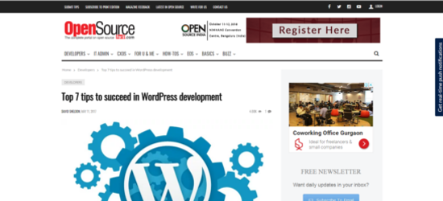](http://opensourceforu.com/2017/05/tips-succeed-wordpress-development/)

A goal-focused, self-motivated, accomplished content developer with unique abilities in conceptualizing, writing, and editing the high-quality technical / non-technical web content for B2B / B2C portal e-commerce platforms, websites, articles, blogs, PRs, slides, infographics, and newsletters, seeking position as a Manager / Assistant Manager / Team leader in an organization to boost its KPIs through the proven content development and organizational skills.

**Custom**

yahoo-logo.png

**6 big mistakes startups make while hiring an app development firm**

[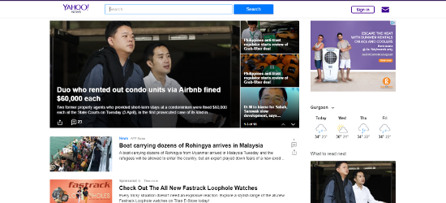](https://sg.news.yahoo.com/6-big-mistakes-startups-while-hiring-app-development-050332380.html)

**Languages -** Proficiency in English and Hindi  
**Technical Skills -** Microsoft Word, Microsoft PowerPoint, GIMP (Image Editor), Adobe Flash (Animation), HitFilm (Video Editing) and Audacity (Sound Editor), HTML, and CSS.

**Work History**

**April 2016 – Present**

**Assistant Manager – Content Development** **and** **Associate SEO Advisor**   
*RAPIDSOFT TECHNOLOGIES*

* Create and manage the content strategy and a variety of content forms, like deeply researched technology articles, blogs, slides, and infographics.
* Conceptualize the content-flow and design of web pages accordingly to current market trends and create the content that helps SEO team quickly get rankings in search engines
* Handle content team and take care of the content promotion and marketing strategy by timely producing deliverables
* Conceptualize graphics / images for social media promotion requirements
* Track trends on social media platform and providing catchy copy, title and description
* Track pages through Google analytics and help in crafting meta keywords, description, titles, etc.
* Manage CMSs like WordPress and Magento an push content routinely
* Edit web HTML and CSS of web pages



**Complete planning of the website’s front-end design and content.**

[](http://watsooexpress.com/)

**Jan 2012 – March 2016**

**Sr. Content Writer**   
*RAPIDSOFT TECHNOLOGIES*



**Complete planning of the website’s front-end design and content.**

[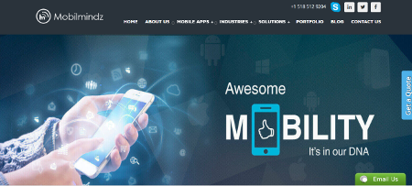](http://www.mobilmindz.com/)

* Created original content for web pages blogs and press releases, online marketing and promotion campaigns
* Created content e-commerce product description, B2B, B2C platforms, portal, various other internet channels
* Handled the task of writing unique titles and descriptions for various web pages
* Handled the responsibilities of reviewing and editing articles written by subordinates



**Rapidsoft Technologies’ content and blogs**

[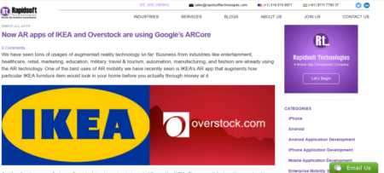](http://www.rapidsofttechnologies.com/blog/)

**Jan 2010 – Jan 2012**

**Sr. Content Writer / Editor, QC**   
*LINXSMART TECHNOLOGIES (A subsidiary of Eperium Business Solution)*

* Performed the tasks Quality Check and Quality Approval of nearly 2,000 websites of the company’s clients.
* Handled e-commerce content for the websites created with Magento CMS



**The advantages and disadvantages of developing Android apps with Kotlin**

[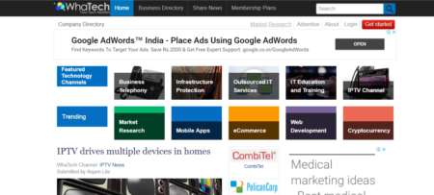](https://www.whatech.com/mobile-apps/blog/362701-the-advantages-and-disadvantages-of-developing-android-apps-with-kotlin)

* Handled the operations of creating B2B and e-commerce website content on project-basis
* Handled the task of writing unique titles and descriptions for various web pages

**March 2009 – Jan 2010**

**Content Writer / Editor**  
*LINXSMART TECHNOLOGIES (A subsidiary of Eperium Business Solution)*



**Top 10 WhatsApp Tips & Tricks To Try in 2017**

[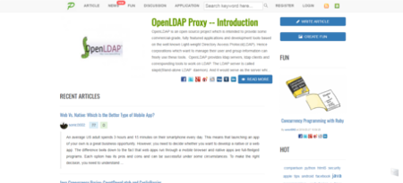](https://www.pixelstech.net/article/1485935622-Top-10-WhatsApp-Tips-&-Tricks-To-Try-in-2017http:/atulyanath.com/)

* Handled the responsibilities of reviewing and editing articles to ensure its quality
* Created Content for clients’ websites
* Dispatched Content for SEO articles, blogs, press release and guest posts.
* Created content creation for newsletters, punch line and marketing headings

**Sept 2008 – Feb 2009**

**Content Writer & Translator**   
*ASTRO INDIA MAGAZINE (Print)*



**Which Is The Best E-Commerce Website Development Technology?**

[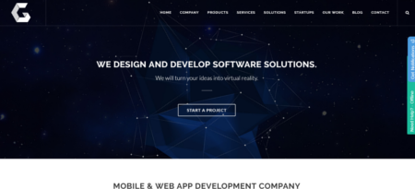](https://www.ingeniumweb.com/blog/post/which-is-the-best-e-commerce-website-development-technology/3597/)

* Created product descriptions
* Created deep research-based content writing operations
* Handled the task of editing and proof reading content before sending it to printing
* Wrote quality articles for a number of astrology-based topics
* Translated Hindi content into quality English content

**Education Qualification**

* Master's degree in Mass Communication, New Delhi, 2007
* Bachelor's degree in Commerce, Jiwaji University, Gwalior, 2003

**Persona Details**

* Name: Vivek Verma
* Date of Birth: 08/03/1982
* Employment Status: Full time
* Civil status: Married

**Date_________ Vivek Verma**